Guide to Java in Arch Linux

horizontal line

**First version: OCTOBER 26, 2022 / 11:40 AM CT  
Last update: OCTOBER 26, 2022 / 11:40 AM CT  
  
Based on the Arch Wiki**[**https://wiki.archlinux.org/title/java**](https://wiki.archlinux.org/title/java) **00 Overview**

1. Arch Linux officially supports the open source OpenJDK versions 8, 11, 17 and 18. All these JVM can be installed without conflict and switched between using helper script archlinux-java. Several other Java environments are available in AUR but are not officially supported.

**01 Installing Java  
[https://wiki.archlinux.org/title/java#Installation](https://wiki.archlinux.org/title/java" \l "Installation)**

1. Two common packages are respectively pulled as dependency, named java-runtime-common (containing common files for Java Runtime Environments) and java-environment-common (containing common files for Java Development Kits). The provided environment file /etc/profile.d/jre.sh points to a linked location /usr/lib/jvm/default/bin, set by the archlinux-java helper script.

**02 Switching between JVMs**

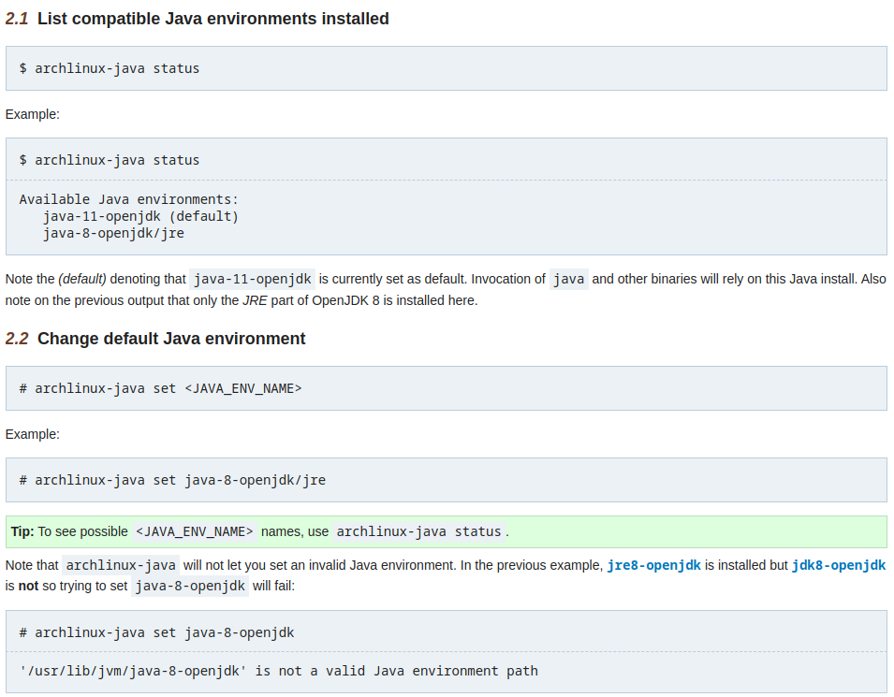

** NOTICE: I cannot and will not be liable responsible for any lost of data or information, nor any damage to your hardware. THE SOFTWARE IS PROVIDED “AS IS”, WITHOUT WARRANTY OF ANY KIND, EXPRESS OR IMPLIED, INCLUDING BUT NOT LIMITED TO THE WARRANTIES OF MERCHANTABILITY, FITNESS FOR A PARTICULAR PURPOSE AND NONINFRINGEMENT. IN NO EVENT SHALL THE AUTHORS BE LIABLE FOR ANY CLAIM, DAMAGES OR OTHER LIABILITY, WHETHER IN AN ACTION OF CONTRACT, TORT OR OTHERWISE, ARISING FROM, OUT OF OR IN CONNECTION WITH THE SOFTWARE OR THE USE OR OTHER DEALINGS IN THE SOFTWARE. **